DSCI560 Lab1 Report
Name: Yuxuan Liu, USC ID: 4780355176
https://github.com/paracosmgracee/usc-ds560-25sp/tree/main/lab1

1. Installation and Setup
1.1. Install VMware
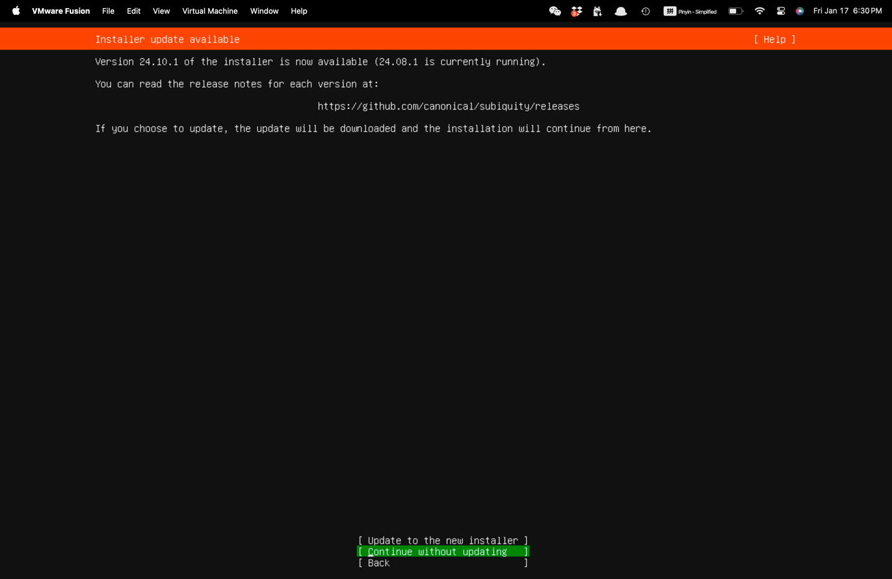
Shows the VMware installation screen, indicating the setup process for the virtual machine.

1.2. Download Ubuntu ISO Image
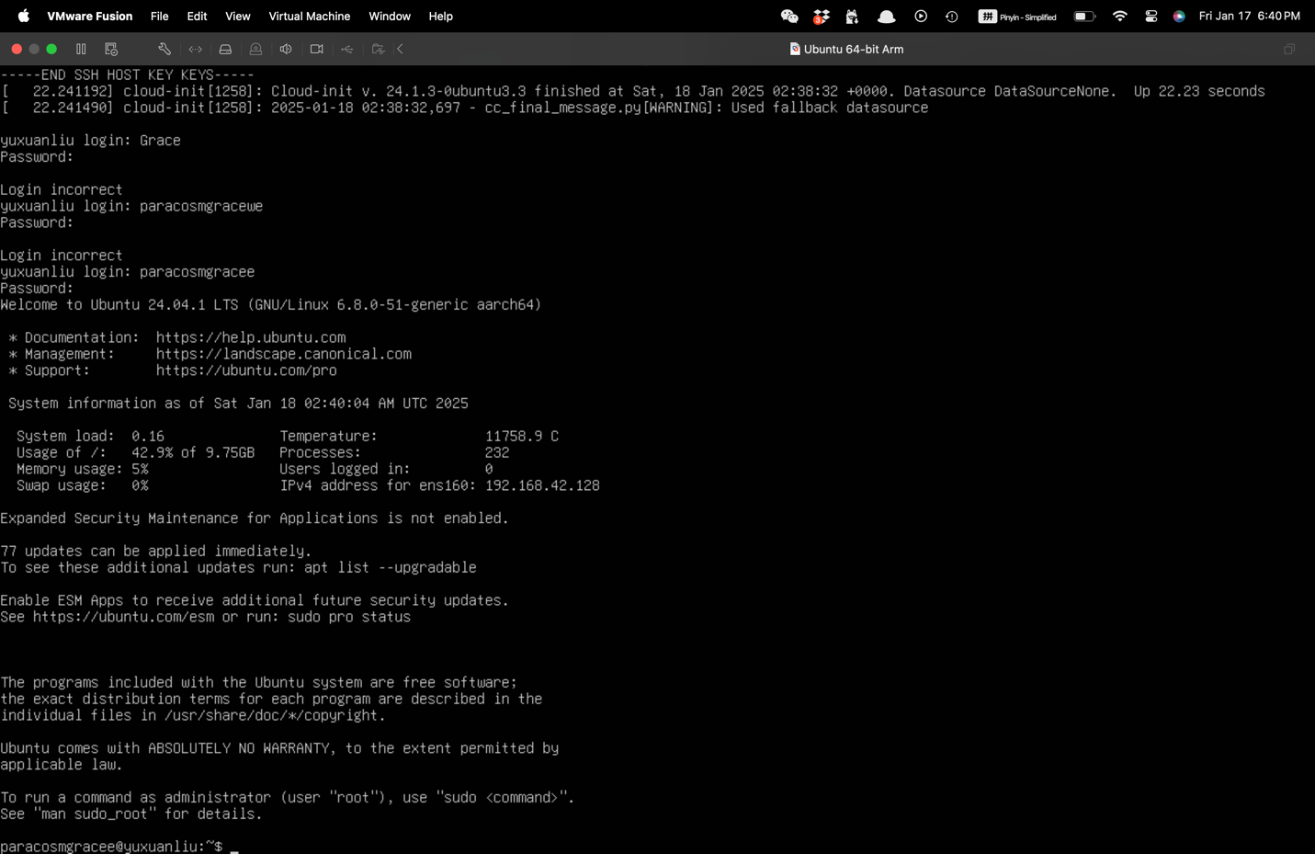
Displays the Ubuntu ISO image download page, highlighting the steps to acquire the necessary operating system.

1.3. Install Python on Linux
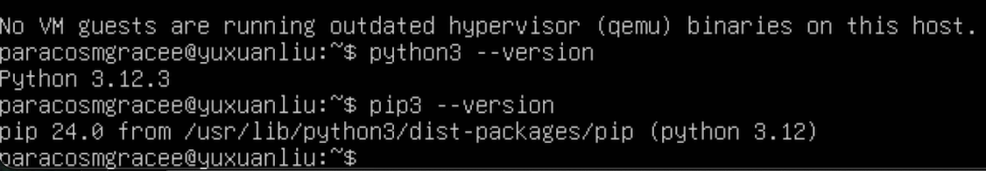
Shows the Linux terminal with commands to install Python 3 and verify the version.

2. Get Familiar with Linux and Python
2.1. Playing around with Linux Terminal
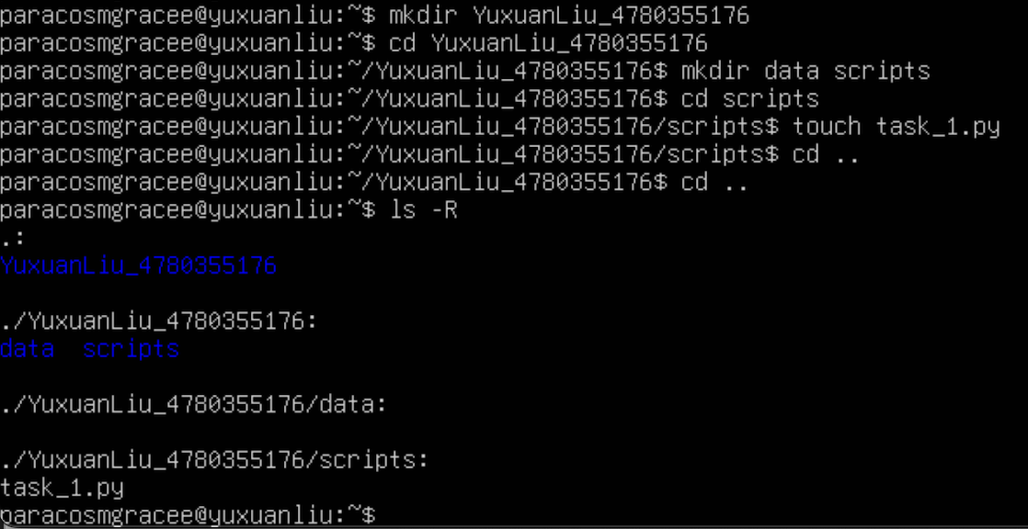
Depicts the Linux terminal, where the student has created a directory, subdirectories, and a Python file.

2.2. A basic Python Script
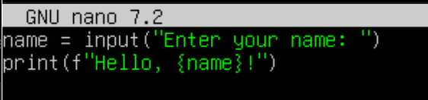
Shows the Python script that prompts the user for their name and outputs a greeting.
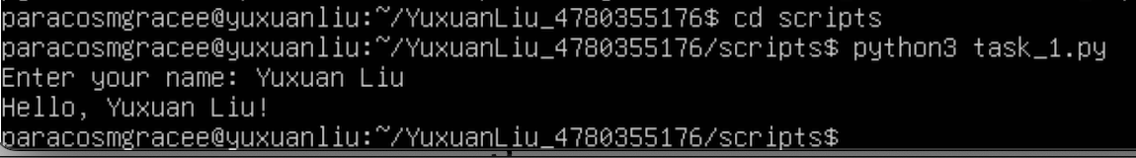
Displays the terminal output of the Python script running.

2.3. Python Web-scraping Task
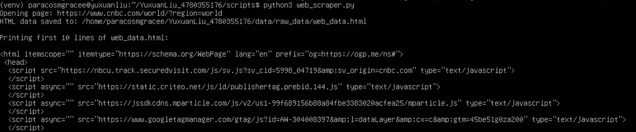
Indicates the Python script being written to perform web scraping from the CNBC website.

2.4. Data Filtering Task
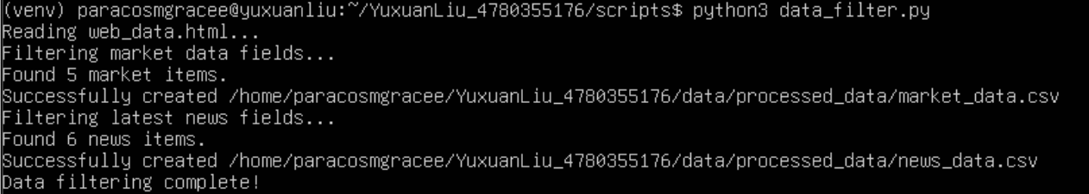
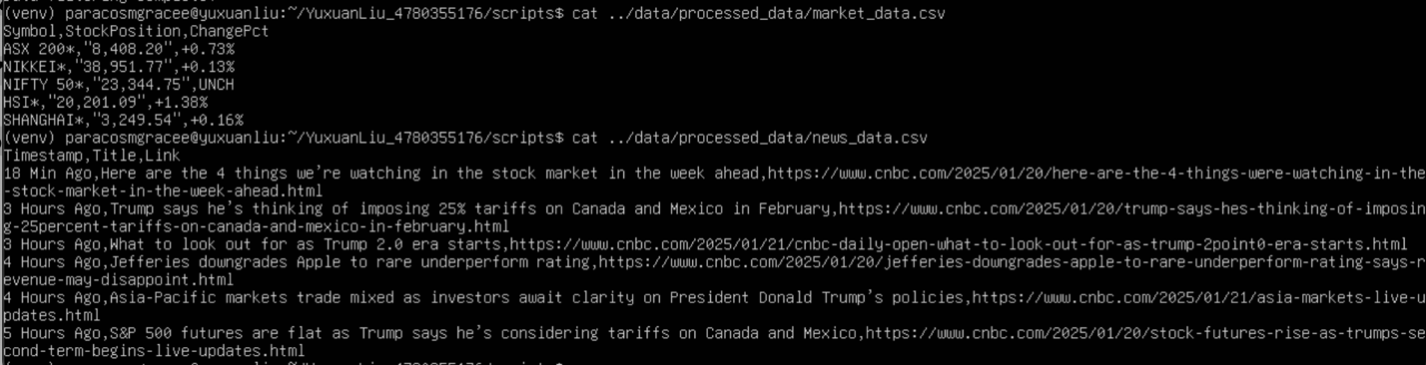
Shows the terminal output (market_data.csv and news_data.csv) when running the data filtering script.

